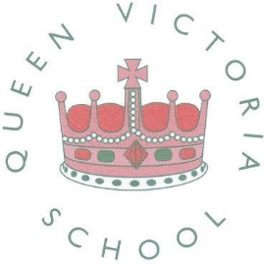

SCHOOL NEWSLETTER – ISSUE 3 – 5 OCTOBER 2018 | Dear All  Firstly thank you for attending our recent coffee morning/afternon - it was lovely to meet so many of you. We managed to convince some of you to help out in school and hear children read. Don’t worry, we still need volunteers for Reception.
 | Roles and Responsibilities
Mrs Rindl is delighted to announce the Head Boy and Head Girl. Joseph and Pheobe from Year 6 have been nominated by senior staff to this very important role. They are ideal ambassadors for our schol and join the House Captains on Mrs Rindl’s Leadership Team.

Welcome from our New Head Boy and Girl

Pheobe said ”I have been at this school since I was 3 years old. I was very grateful when I found out I was going to be working with Mrs Rindl and other members of staff. Also taking care of important jobs for Mrs Rindl. I am very happy to be Head Girl and to take care of other pupils, and to be working with Joseph (Head Boy)”.

Joseph said “It was a really big shock when I got chosen for Head Boy, I wasn’t expecting it at all. My name is Joesph and I’m in Year 6. The other day Mrs Rindl (our new Head Teacher) asked me to come to her office and announced to me and Pheobe in 6D that we are Head Boy and Girl. It felt amazing! I thought my friend called Jacky would get chosen because he is really sensible. Additionally, me, Phoebe and Mrs Rindl are in charge of the Senior Leadership Team. I cannot wait to do all the activities as Head Boy”.

There are also lots of jobs to do around school, so we have decided to increase the number of School Prefects. These children have been recommended by teaching staff and will be on duty at different times during the week. Congratulations to them all!

6B 6D 6N
Zaina Ellie Niamh C
Ella Leah Megan
Jak Bethany Niamh I
Sophie Jhenae Harrison
Lewis Thomas Chelsi
Alfie Marley Jack

 | Congratulations to
 | Isla 1B and Sophie 6D who both won the colouring competition organised by Dudley Catering. | Connor 5B as he is the only person in the school to hold 3 GOLDEN TICKETS!

 | House Winners
 | Bell: 546  Dickens: 693  Nightingale: 716 |  |  |  |  | Congratulations to Nightingale who currently lead the way.
 | Haloween Disco
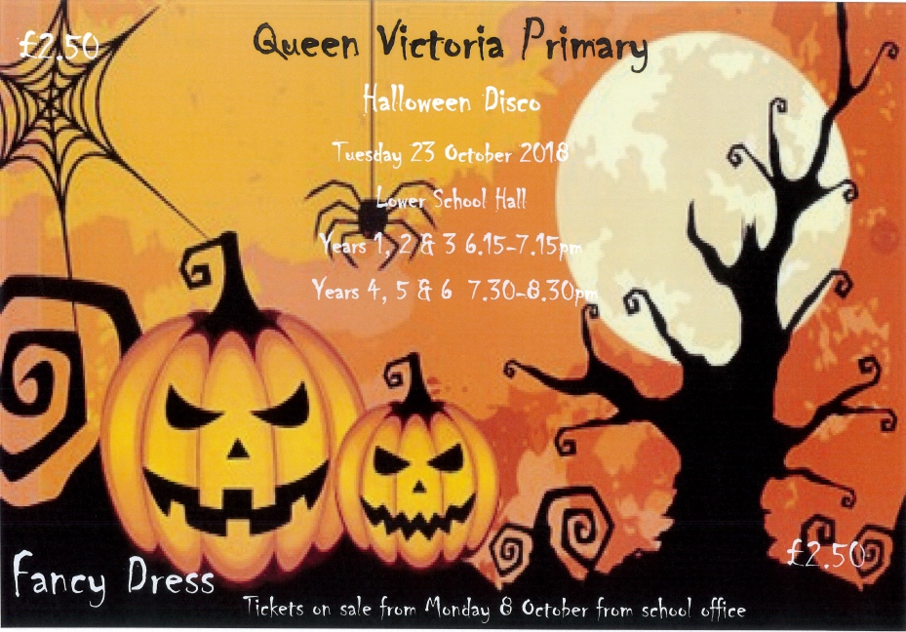Tickets for the disco go on sale on Monday 8th October and can be purchased from the school office. Tickets are only £2.50.

Please note that the school have to follow strict rules about child supervision and for that reason no parents will be allowed to stay for the event, but rest assured that your children will be safe with our dedicated staff team who organise these events.
 | Reminder - Parents Evening
 | Parents Evening letters will be sent home on Monday 8th October - please complete and return as soon as possible. |  |  |  | Please note children in 1B - Parents Evening is now on 10th October. A letter is coming home tonight.
 | Macmillan Coffee Morning
 | We are pleased to annouce the we raised £500.00 from the Macmillan Coffee morning on Friday 29 September. I would like to take this opportunity to thank you all for your very generous donations of cakes and also for coming along to the coffee morning to support this most worthy cause.
 |  | Charity Sponsorship
 |  | Well done to Liberty in Year 6 who was very brave and had 9 inches cut off her hair to raise funds for the Little Princess Childrens Cancer charity. Liberty not only raised funds but also donated the hair.
 |  |  | ParentPay - Update
 | Staff are working hard to get all of the details into the ParentPay system. It is hoped that the system will go live after half term. Parents should look out for a letter which will be sent home on Monday 8th October. A leaflet will also be available at parents evening, and your activation code will be sent out week commencing 15th October.
 | School Photographs
 | Photographs were taken earlier in the week. Proofs will be sent to the school shortly, for distirbution. We would like to remind you that all photographs need to be purchased on-line. There will be full instructions within your photograph proof pack. The school is not able to take money for photographs.
 | Diary Dates
 | Parents Evening  Halloween Disco  Half Term  School Closed  Start of Term |  |  | Wednesday 17th October  Tuesday 23rd October  Thursday 25th October  Friday 26th October  Monday 5th November

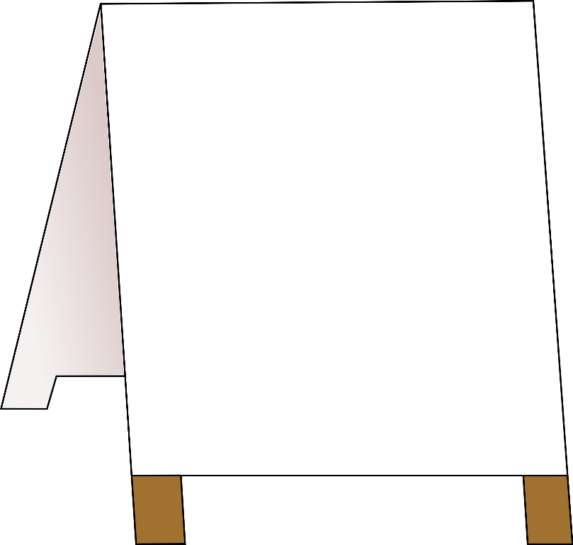
COMING SOON
OUR FIRST EDITION OF
‘THE PIONEER POST’

A new magazine written by our children, for our children.

