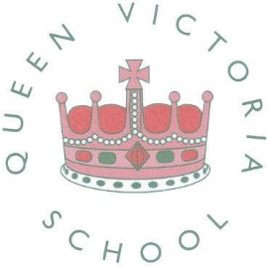

SCHOOL NEWSLETTER – ISSUE 5 – 15 NOVEMBER 2018 | Dear All  Many thanks to all those who have already given money for Children in Need today – we will let you know how much we raised.  Across school we have been encountering a number of issues between children related to online gaming. Often incidents that have taken place between children are being brought into school causing both upset and conflict.  As a school we are going to bring in Online Safety Training for our children. We |  | 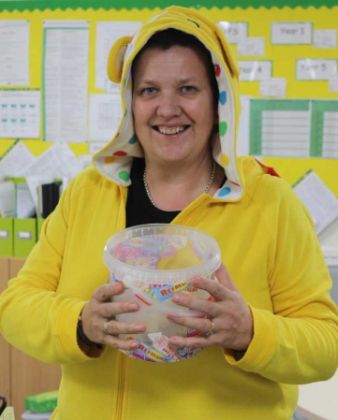
would also welcome parents support with this, in monitoring what your child may be sending out via text, or over a game, and also what your child may receive.

Finally, thank you to all those who have signed up to our online payment system. If you need any help, lost the password etc, do speak to the school office.

 | CHANGES TO PPA AT QUEEN VIC
All teachers are entitled to time during the working week to plan, prepare and assess (PPA). At Queen Vic, this time (10%) has previously been covered by a member of our support staff. From next week Junior Jam will be providing this cover, allowing our support staff team to focus on intervention and booster groups, across school.

Junior Jam will be providing the following activities: ICT, PE and Music, run by qualified teachers.

Your child will get over the next 2 terms, the opportunity to do animation, film making, play African drums, write their own song, athletics, cricket and even boxercise, to name a few.

Please ensure your child has their PE kit in school on the day below.

Children, in the morning, will not have an outdoor break, but will have a ‘snack stop’ between activities.

 | 9.30am – 12 noon | 1pm – 3.30pm
Tuesday | Year 6 | Year 3
Wednesday | Year 4 | Year 2
Thursday | Year 5 | Year 1

 | COMING NEXT WEEK
- New year group curriculum plans for this half term.
- New Reading logs with plenty of space for parent and teacher comments

Look out for these in your child’s bag.

 |  | UNICEF
For more than 70 years, UNICEF has led the global fight for children’s rights. UNICEF works in 190 countries and territories, to protect the rights of every child. Queen Victoria Primary School has joined UNICEF to make a direct impact in the lives of the world’s most vulnerable children. Our aim is to join our voice with theirs and make a difference to the lives of children. As a school, we will be promoting and protecting children's rights. A group of children and staff will work together to help promote children's rights and responsibilities.

We are pleased to tell you that the children helping to support the programme are: Daisy 5B, Brianna 4N, Sophie 4D, Ishaan 4B, Sean 5B, Tyler 5N, Lily-Mae, 5D – another example of Queen Vic Pioneers in action!

 | Tristan – Year 6
Tristan has been presented with the Pride of Birmingham Award for his work in raising £600, to purchase essential supplies for Bimingham’s homeless community.

Tristan has always taken food for a homeless man, who sits outside a theatre in Dudley. However on an evening visit to a Birmingham theatre Tristan noticed that there were a lot of homeless people on the streets. A few days later, Tristan said to his mom that he would like to go back to visit the homeless at Christmas and take them bags of goodies. Tristan got gloves, hats, food and drink which he distributed.

People who received gift bags said “what he was doing was brilliant”, “he has a heart of gold” “he is the salt of the earth”.

Tristan, we are so proud of you. Well done a real Queen Vic Pioneer!
 | 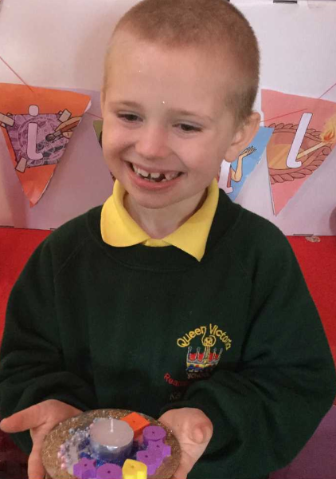 | Nurture Celebrate Diwali |  |  |  | 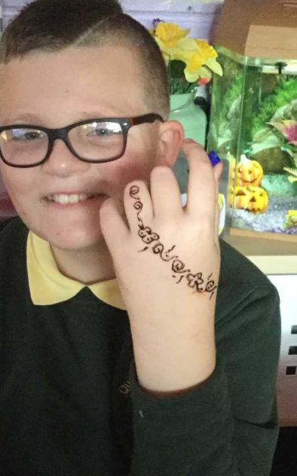
 |  | We enjoyed celebrating Diwali by taking part in a variety of fun and creative activities. This involved Bhangra Dancing, Mehndi Patterns, Indian Food Tasting and Cooking which enabled us to raise £29.40, which we donated to charity
 |  |  | HOLD THIS DATE
QUEEN VICTORIA’S
CHRISTMAS FAYRE
THURSDAY 13th DECEMBER
5PM – 7PM
 | Own Clothes Days
As announced above, the school are going to be holding a Christmas Fayre on Thursday 13th December. We are therefore giving the children an opportunity to come in their own clothes and in return bring in a donation for the fayre.

Wear your own clothes on

Friday 30 November Friday 7 December
Donate a bottle, tin or toiletries Donate chocolate or sweets for the famous Mrs Rindl Chocolate Stall

 | Diary Dates
 | Start of Term  Children in Need  Years 1 and 2 Pantomime (in school)  Nursery Christmas Performance  School Christmas Lunch  Inclusion Team – Coffee Morning (by invite only)  Reception Christmas Performance  10am – 11am and 1.30pm – 2.30pm  Christmas Fayre  Christmas Jumper Day  Reception Christmas Trip - Safari Park  Praise Assembly (Year 1 to 6 - invitation only)  School Carol Concert  Year 1 Party Day  Reception Party Day  Nursery Party Day  Time for Twos Party Day  School Closes for Christmas  School Opens  Year 2 – 6 Party Days to be announced shortly |  |  | Monday 5 November  Friday 16 November  Tuesday 27 November  Thursday 6 December  Wednesday 12 December  Wednesday 12 December  Thursday 13 December  Thursday 13 December – 5pm to 7pm  Friday 14 December  Wednesday 19 December  Wednesday 19 December  Thursday 20 December  Friday 21 December  Friday 21 December  Friday 21 December  Friday 21 December  Friday 21 December  Monday 7 January

 | Nurture Sale
Nutur | The children in Nuture will be selling biscuits during next half term. Below are the dates and the year groups they will be selling to.
Dates | Year Group | Sale
19 November | 5 & 6 | Curiosity Cupcakes - 30p
26 November | 1 & 2 | Mini Me Biscuits - 30p
3 December | 3 & 4 | Christmas Jumper Biscuits - 30p

All sales will take place on the Friday of that week!
 | Christmas Light Switch on in the Borough
Saturday 17th November Halesowen Christmas Lights Switch on
Saturday 17th November Merry Hill Centre Christmas Lights Switch on
Saturday 24th November Dudley Christmas Lights Switch on
Friday 30th November Brierley Hill Christmas Lights Switch on
Friday 30th November Kingswinford Christms Lights Switch on
Saturday 1st December Stourbridge Christmas Lights Switch on
Saturday 1st December Gornal Chrismas Lights Switch on

Further information is available at:
http://www.dudley.gov.uk/news/dates_announced-for-christmas-light-switch-on-events/

 | Rockies Youth Club
This is a Youth Club catering for young people with Special Educational Needs and disabilities, ages 11 - 25 years.

The club runs on a Tuesday evening from 18:00 - 20:30.
It is based at Lower Gornal Youth Centre, Temple Street, DY3 2PE.

See poster information about a Christmas Party they are holding below.

