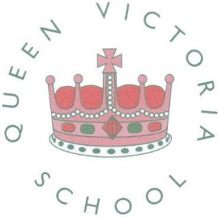

23rd January 2019

Dear Parents/Carers

On Friday 1st February Queen Victoria Primary School will be taking part in Number Day 2019 raising money for NSPCC. Throughout the school there will be various Maths activities for your child to enjoy.

There will also be a Maths Quiz that your child can enter and for a 50p fee. All years in the school will have the opportunity to enter and all proceeds collected will be donated to the NSPCC.

There will be a prize for every year group. The prizes for the winners will be given out on Monday 4th February.

Please give kindly as the NSPCC is a valued charity and supports the rights of
children.

Yours sincerely

Mrs C Rindl
Head Teacher

